|  |
| --- |
|  |
| **Health-CARE MANAGEMENT** |
| A PROJECT REPORT Submitted by NAME CLASS XII |
|  |
| OUR OWN ENGLISH HIGH SCHOOL , SHJ |
| 2019-2020 |

|  |
| --- |
|  |

**Our Own English High School, Sharjah**

## ~AUT0004Certificate

This is to certify that ___________________________ of class ________ Registration No. ______________ has satisfactorily completed the project work in Computer Science during the academic year 2019-20 as prescribed by C. B. S. E, New Delhi, India.

Date of Examination: __________

__________ ____________

Signature of Signature of

Teacher-in-charge External Examine

**ACKNOWLEDGEMENT**

**It gives me immense pleasure in presenting this project. I would like to express my heartfelt gratitude to my teacher Ms. Mini who guided me in the course of this project and gave me this enlightening opportunity. I would also like to express my gratitude to anyone who has directly or indirectly contributed towards the success of this project.**

**With their guidance I have deeply understood the importance and depth of computer science as a subject.**

**ABSTRACT**

**This Health Care management information system refers to a computer based system that equips hospitals with the tools to organize, evaluate and efficiently manage data. It outlines the requirement and functional aspects covered in e-Health Care Management. It lists out all the essential requirements for the client so as to provide expected quality and output from the application .It provides the benefits of improved response, cost control and improved profitability.**

**TABLE OF CONTENTS**

1. **BONAFIDE CERTIFICATE**
2. **ACKNOWLEDGEMENT**
3. **ABSTRACT**
4. **SYSTEM SPECIFICATIONS**
5. **PROJECT OVERVIEW**
6. **DATA FILE DESIGN**
7. **CLASS DESCRIPTION**
8. **FLOWCHART**
9. **PROGRAM SOURCE CODE**
10. **OUTPUT SCREEN SHOTS**
11. **BIBLIOGRAPHY**

**SYSTEM SPECIFICATIONS**

1. **HARDWARE REQUIREMENT**

|  |  |
| --- | --- |
| **PROCESSOR:** | PENTIUM PROCESSOR WITH WINDOWS OS |
| **MEMORY:** | 512 MB |
| **DISK CAPACITY:** | 1 GB |

1. **SOFTWARE REQUIREMENT**

BORLAND C++

**PROJECT OVERVIEW**

**A system is needed that can maintain hospitals daily routine without cumbersome and prone to error manual procedures. This study focuses on the general management of the hospital.**

**This program mainly consists of: 1.Registration of patients – it registers a new ID and also allows a prior patient to view their past check-up reports.2.General health checkups – provides various checkups such as heart rate, BMI, cholesterol, etc. 3. Appropriate prescriptions – provides simple tips to regain health in required aspects. 4. Updating of reports – updates report after every consequent check-up.**

**DATA FILE DESIGN**

**TEXT/BINARY FILES USED:**

**HospitalRecords1.dat**

|  |  |  |
| --- | --- | --- |
| **S.NO** | **FIELD NAME** | **FIELD DESCRIPTION** |
| **1** | **Name** | **NAME OF PATIENT** |
| **2** | **age** | **AGE OF PATIENT** |
| **3** | **gender** | **GENDER OF PATIENT** |
| **4** | **contact** | **CONTACT NUMBER OF THE PATIENT** |
| **5** | **id** | **IDENTITY NO.** |

**Info.txt**

**Information about the Healthcare.**

**CLASS DESCRIPTION**

|  |
| --- |
| **class checkup** |
| **DATA ATTRIBUTES**  **float vitD**  **float chtrl**  **float hrate**  **float ht**  **float wt**  **float BMI** |
| **METHODS**  **void check()**  **float retvitD()**  **float retchtrl()**  **float rethrate()**  **float retht()**  **float retwt()**  **float retBMI()**  **void report()** |

|  |
| --- |
| **class Patient_info** |
| **DATA ATTRIBUTES**  **char Name[20]**  **char gender**  **int age**  **long contact**  **double id** |
| **METHODS**  **void Register()**  **int retid()**  **int retage()**  **long retcont()**  **char*retname()**  **char retg()**  **void display()** |

**FLOWCHART**

void main()

Declare and initialize

Patient_info P;

char cont='y',d,ch,c=3,str[50];

int flag=0,id=201900;

Display WELCOME &Title Page

**YES**

while (cont=='y')

Display Menu

A

Enter choice:

cin>>d;

E

D

C

case '1':

case '4':

case '3':

B

case '2':

A

**YES**

**YES**

**YES**

**YES**

**NO**

**NO**

**NO**

**NO**

while(file.read((char*)&P,sizeof(P)))

**YES**

Record is not found

**NO**

**YES**

**YES**

**NO**

flag=1

P.display(id);

“Welcome:"

<<P.retname();

P.retid()==id

file.close();

break;

flag==0

B

Enter your Id:";

cin>>id ;

file.open("Info.txt", ios::in);

D

Display text

while(file)

C

Open File"Info.txt"

**YES**

**NO**

Close File

break;

Exit

Display Thank You

**YES**

**NO**

Display id;

P.Register(id);

Close File

**NO**

**YES**

**YES**

F

ch=='2'

while(file.read((char*)&P,sizeof(P)))

E

1.New registration

2.Old registration.

Input ch;

ch=='1'

Open File HospitalRecords1.dat

id=P.retid()+1;

Enter Id:

cin>>id ;

ch='n';

Open File HospitalRecords1.dat

while(file.read((char*)&P,sizeof(P))&&(ch=='n'))

{

**NO**

P.check();

P.display(id);

Display Record not found

**NO**

flag==0

Close File

**YES**

Display Welcome:"<<P.retname();

flag=1;

**YES**

**NO**

(ch=='y'||ch=='Y')

**YES**

Display Name:"<<P.retname()

Confirm Name

P.retid()==id

**YES**

F

Open file HospitalRecords1.dat

Get details: Name, age, gender, contact

Register(int i)

check();

display(id);

Write into HospitalRecords1.dat

Close file

Return void

check()

Get details: vitD, chtrl, hrate, wt, ht

Return void

Return void

report();

Display details: vitD, chtrl, hrate, wt, ht,BMI

Display details: Name, age, gender, contact,id

display(id)

BMI=wt/(ht*ht);

**NO**

**NO**

**YES**

vitD>=20&&vitD<80

Return void

Sufficient levels of Vitamin D

Excess Vitamin D

Vitamin D Deficient

vitD<20

report()

**YES**

High

Cholesterol

**YES**

**YES**

**NO**

**NO**

Borderline High Cholesterol

chtrl>=200&&chtrl<=239

chtrl<200

Healthy cholesterol

hrate>=60&&hrate<=100

**YES**

**NO**

Slow heart rate

hrate<60

Normal heartrate

Fast heart rate

**YES**

**NO**

**YES**

**NO**

BMI<18.5

Underweight

Overweight

Normal weight

BMI>=18.5&&BMI<=24.9

Obese

**YES**

BMI>=30

**YES**

**NO**

**NO**

**PROGRAM SOURCE CODE**

#include<dos.h>

#include<fstream.h>

#include<conio.h>

#include<stdlib.h>

#include<stdio.h>

class checkup

{

float vitD;

float chtrl;

float hrate;

float ht,wt,BMI;

public:

void check()

{

cout<<"\n\t ---------------------------------------";

cout<<"\n\n\t\t\t Health Checkup\n";

cout<<"\n\tVitamin D: ";

cin>>vitD;

cout<<"\tCholestrol: ";

cin>>chtrl;

cout<<"\tHeart rate: ";

cin>>hrate;

cout<<"\tHeight(m): " ;

cin>>ht;

cout<<"\tWeight(kg): " ;

cin>>wt;

BMI=wt/(ht*ht);

cout<<"\n\n\n\n\t\t\tPress any key-> VIEW REPORT";

}

float retvitD()

{return vitD; }

float retchtrl()

{ return chtrl;}

float rethrate()

{return hrate; }

float retht()

{return ht;}

float retwt()

{return wt;}

float retBMI()

{return BMI;}

void report()

{

cout<<"\n\n\t\tREPORT\n";

{

if(vitD<20)

{

cout<<"\n\tVitamin D Deficient";

cout<<"\n\t\tTips:Spend time in sunlight.";

cout<<"\n\t\tConsume fatty fish and seafood.";

cout<<"\n\t\tEat more mushrooms";

}

else if(vitD>=20&&vitD<80)

cout<<"\n\tSufficient levels of Vitamin D";

else

cout<<"\n\tExcess Vitamin D";

}

{

if(chtrl<200)

cout<<"\n\tHealthy cholestrol";

else if(chtrl>=200&&chtrl<=239)

{

cout<<"\n\tBorderline High Cholestrol";

cout<<"\n\t\tTips:Exercise regularly. ";

cout<<"\n\t\tEat a healthydiet.";

}

else

{

cout<<"\n\tHigh Cholestrol";

cout<<"\n\t\tTips:Reduce saturated fats.";

cout<<"\n\t\tEat foods rich in omega-3 fatty acids.";

}

}

{

if(hrate>=60&&hrate<=100)

cout<<"\n\tNormal heartrate";

else if(hrate<60)

cout<<"\n\tSlow heart rate";

else

{

cout<<"\n\tFast heart rate";

cout<<"\n\t\tTips:Exercise more. ";

}

}

{

if(BMI<18.5)

{

cout<<"\n\tUnderweight";

cout<<"\n\t\tTips:Eat more frequently.";

cout<<"\n\t\tChoose nutrient-rich foods";

}

else if(BMI>=30)

{

cout<<"\n\tObese";

cout<<"\n\t\tTips:Engage in regular physical activity.";

cout<<"\n\t\tKeep a food and weight diary.";

}

else if(BMI>=18.5&&BMI<=24.9)

cout<<"\n\tNormal weight";

else

{

cout<<"\n\tOverweight";

cout<<"\n\t\tTips:Engage in regular physical activity.";

cout<<"\n\t\tKeep a food and weight diary.";

}

}

}

};

class Patient_info :public checkup

{ char Name[20],gender;

int age;

long contact;

double id;

public:

void Register(int i)

{

fstream file("HospitalRecords1.dat",ios::binary|ios::app);

cout<<"\n\n\t\t\t\tREGISTRATION FORM";

cout<<"\n\tName:";

gets(Name);

cout<<"\tAge :";

cin>>age;

cout<<"\tGender(F/M):";

cin>>gender;

cout<<"\tContact Details:";

cin>>contact;

id=i;

check();

getch();

system ("CLS");

display(id);

file.write((char*)this,sizeof(Patient_info));

file.close();

}

int retid()

{return id;}

int retage()

{return age;}

long retcont()

{return contact;}

char*retname()

{return Name;}

char retg()

{return gender;}

void display(id)

{ cout<<"\n\n\t\t\t\tC++Healthcare\n ";

cout<<"\n\t __________________________________________";

cout<<"\n\n\t\tPATIENT INFORMATION\n ";

cout<<"\n\tName:"<<retname();

cout<<"\n\tAge :"<<retage();

cout<<"\n\tGender:"<<retg();

cout<<"\n\tContact:"<<retcont();

cout<<"\n\tId:"<<retid();

cout<<"\n\t __________________________________________";

cout<<"\n\n\t\tRESUTS\n";

cout<<"\n\tVitamin D:"<<retvitD();

cout<<"\n\tCholestrol:"<<retchtrl();

cout<<"\n\tHeartrate:"<<rethrate();

cout<<"\n\tHeight:"<<retht();

cout<<"\n\tWeight:"<<retwt();

cout<<"\n\tBMI:"<<retBMI();

cout<<"\n\t__________________________________________";

report(); }

}P;

void main()

{ system ("color 3f");

Patient_info P;

char cont='y';

char d,ch;

char c=3;

int flag=0,id=201900;

char str[50];

cout<<"\n\n\n\n\n\n\n\n\t\t\t\tWELCOME";

sleep(1);

system ("CLS");

cout<<"\n\n\n\n\n\t\t________________________________________________";

cout<<"\n\n\n\t\t\t\tC++ HEALTHCARE";

cout<<"\n\n\n\t\t________________________________________________";

cout<<"\n\n\n\t\t\tPress any key->\t";

getch();

for(int x=0;x<3;x++)

{cout<<char(219)<<" ";

sleep(1);

}

while(cont=='y')

{system ("color 8f");

system("CLS");

cout<<"\n\n\n\n\t\t\t\tC++Healthcare App";

cout<<"\n\n\n\t\t________________________________________________";

cout<<"\n\t\t|\t\t\t\t\t\t|\n\t\t|\t\t\tMENU\t\t\t|";

cout<<"\n\t\t|\t1.Medical Checkup\t\t\t|";

cout<<"\n\t\t|\t2.Patient History\t\t\t|";

cout<<"\n\t\t|\t3.Information about the Healthcare\t|";

cout<<"\n\t\t|\t4.Exit\t\t\t\t\t|";

cout<<"\n\t\t|_______________________________________________|";

cout<<"\n\n\n\t\tENTER YOUR CHOICE: ";

cin>>d;

system ("CLS");

system ("color 3f");

switch(d)

{

case '2':

{

cout<<"\n\n\t\t\tC++ Healthcare App\n";

cout<<"\n\t\tEnter your Id:";

cin>>id ;

fstream file("HospitalRecords1.dat",ios::binary|ios::in);

while(file.read((char*)&P,sizeof(P)))

{

if(P.retid()==id)

{system ("CLS");system ("color 0f");

cout<<"\n\t\t\tWelcome :"<<P.retname();

P.display(id);

cout<<"\n\n\t\tPress any key -> Main Menu";

getch();

system ("CLS");

flag=1; }

}

if(flag==0)

{cout<<"\n\n\t\tSorry .Your Record is not found !";

cout<<"\n\t\tPress any key -> Main Menu";

getch();

system ("CLS");

}

file.close();

} break;

case '3':

{

fstream file;

file.open("Info.txt", ios::in);

cout<<"\n\n\n\n\t\t\t\tC++ Healthcare App";

cout<<"\n\n\t\t________________________________________________\n\n";

while(file)

{ file>>str;

if(*str=='#')

cout<<"\n\t";

else

cout<<str<<" ";

}

file.close();

cout<<"\n\n\t\tPress any key -> Main Menu";

getch();

system ("CLS");

} break;

case '4':

{ system ("CLS");

cout<<"\n\n\t\t\t\tC++ Healthcare App\n";

cout<<"\n\t\t\t ---------------------------------------";

cout<<"\n\n\n\n\n\t\t\t\t\Thank You";

cout<<"\t"<<c<<" "<<c<<" "<<c;

cout<<"\n\n\n\t\t\t\tPress any key-> EXIT";

getch();

exit(0);

}

break;

case '1':

{

system ("CLS");

cout<<"\n\n\t\t\t\tC++ Healthcare App\n";

cout<<"\n\t\t ---------------------------------------";

cout<<"\n\n\t\tRegistration detailes: \n\t";

cout<<"\n\t\t1.New registration\n\t\t2.Old registration. ";

cout<<"\n\n\t\tCHOOSE 1 OR 2: ";

cin>>ch;

system ("CLS");

cout<<"\n\n\t\t\t\tC++Healthcare App\n";

if(ch=='1')

{

fstream file("HospitalRecords1.dat",ios::binary|ios::in);

while(file.read((char*)&P,sizeof(P)))

{

id=P.retid()+1;

}

file.close();

cout<<"\n\n\tYour Id:"<<id;

P.Register(id);

getch();

}

if(ch=='2')

{

cout<<"\n\tEnter Id:";

cin>>id ;

ch='n';

fstream file("HospitalRecords1.dat",ios::binary|ios::in);

while(file.read((char*)&P,sizeof(P))&&(ch=='n'))

{

if(P.retid()==id)

{

cout<<"\n\tName :"<<P.retname();

cout<<"\n\n\tPlease confirm your name";

cout<<"\n\tPress 'y' if yes and 'n' if no : ";

cin>>ch;

if(ch=='y'||ch=='Y')

{

system ("CLS");

cout<<"\n\t\t\tWelcome:"<<P.retname();

cout<<"\n\n\t\t\tC++ Healthcare App\n";

flag=1;

P.check();

P.display(id);

cout<<"\n\n\t\tPress any key->Main Menu";

getch();

system ("CLS");

break;

}

}

}

if(flag==0)

{ cout<<"\n\tSorry . Your Record is not found.!";

cout<<"\n\tPress any key -> Main Menu";

getch();

system ("CLS");

}

file.close();

}

} break;

}

}

**}**

**SAMPLE OUTPUTS**

**Welcome Page:**

**Title Page:**

**Main Menu:**

**Choice 1: Medical Check-up**

**Choice 1: Medical Check-up Sub-Choice 1: New Registration**

**Registration form and Health Check-up:**

**Medical Report:**

**Main Menu:**

**Choice 2: Patient History**

**Main Menu:**

**Choice 2: Patient History**

**Record Not Found**

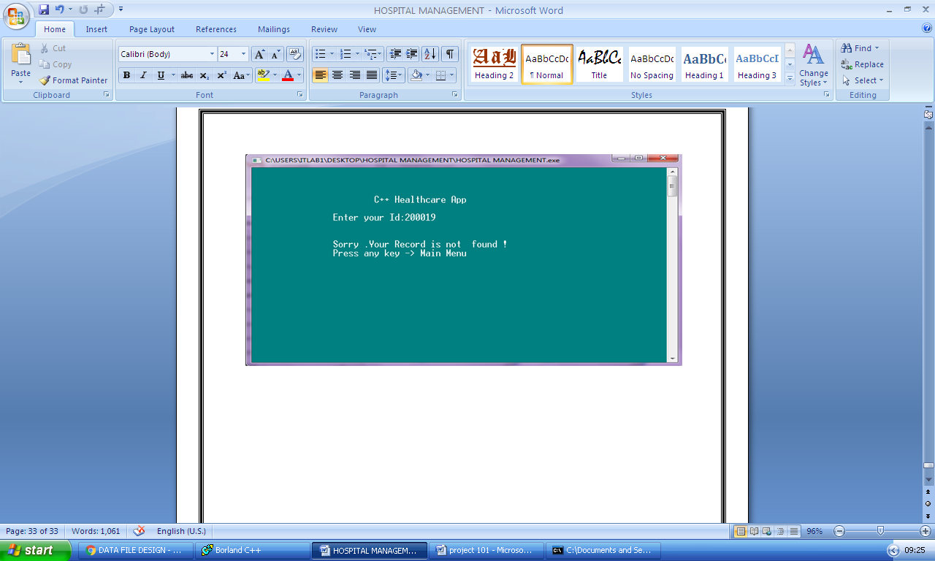

**Main Menu:**

**Choice 1: Medical Check-up**

**Choice 1: Medical Check-up Sub-Choice 2: Old Registration**

**Health Check-up:**

**Medical Report:**

**Main Menu:**

**Choice 3: Information about the Healthcare**

**Main Menu:**

**Choice 4: Exit**

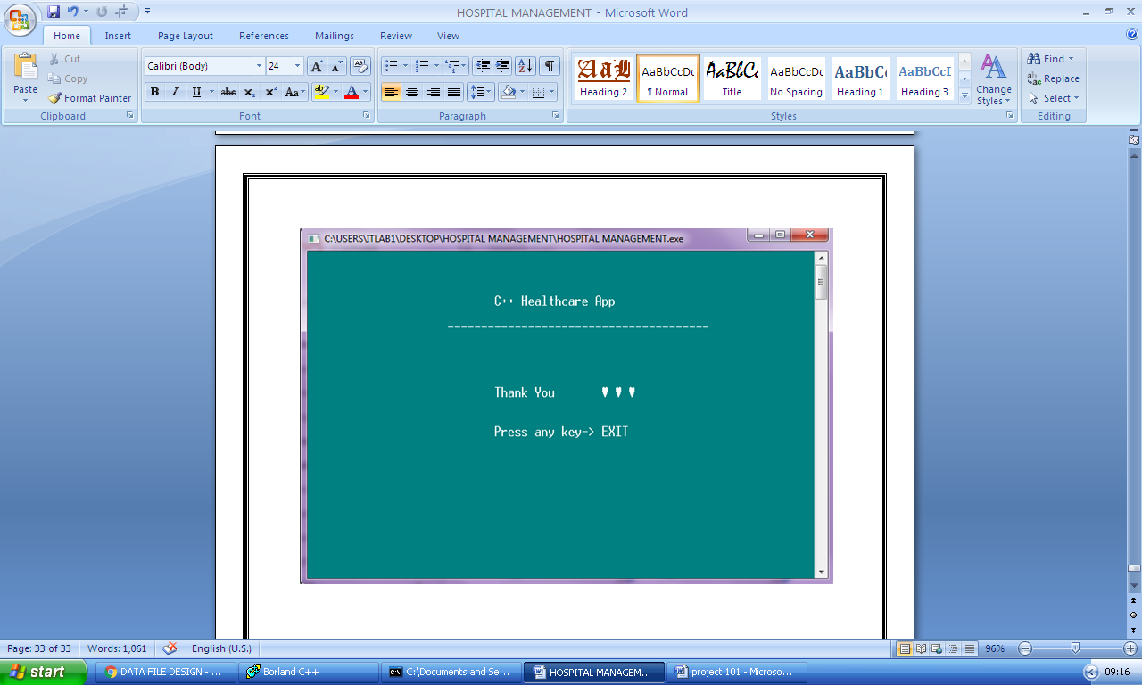

**REFERENCES / BIBLIOGRAPHY**

* **https://code-projects.org/hospital-management-system-in-c-with-source-code/**
* **Sumita Arora: Computer Science with C++ Textbook XII: Volume I & Volume II**